**Lab5 – Understanding Features of Virtual Machine - Azure**

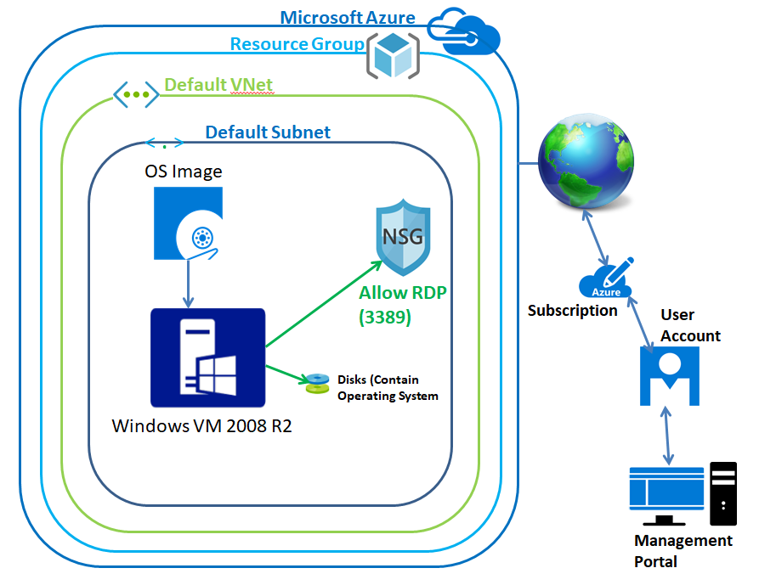

In Azure portal, click **“Virtual machines”**.

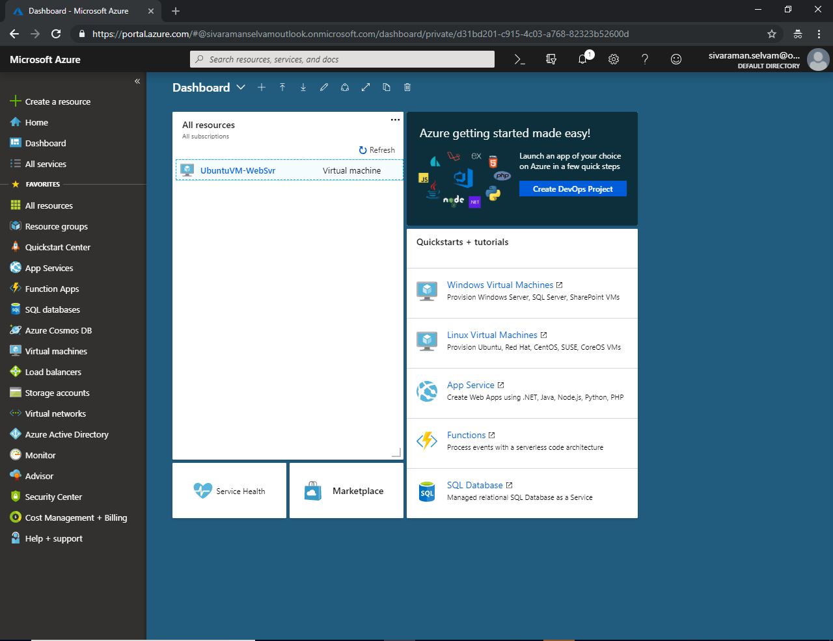

In **“Virtual machines”** click **“Add”** to create virtual machine.

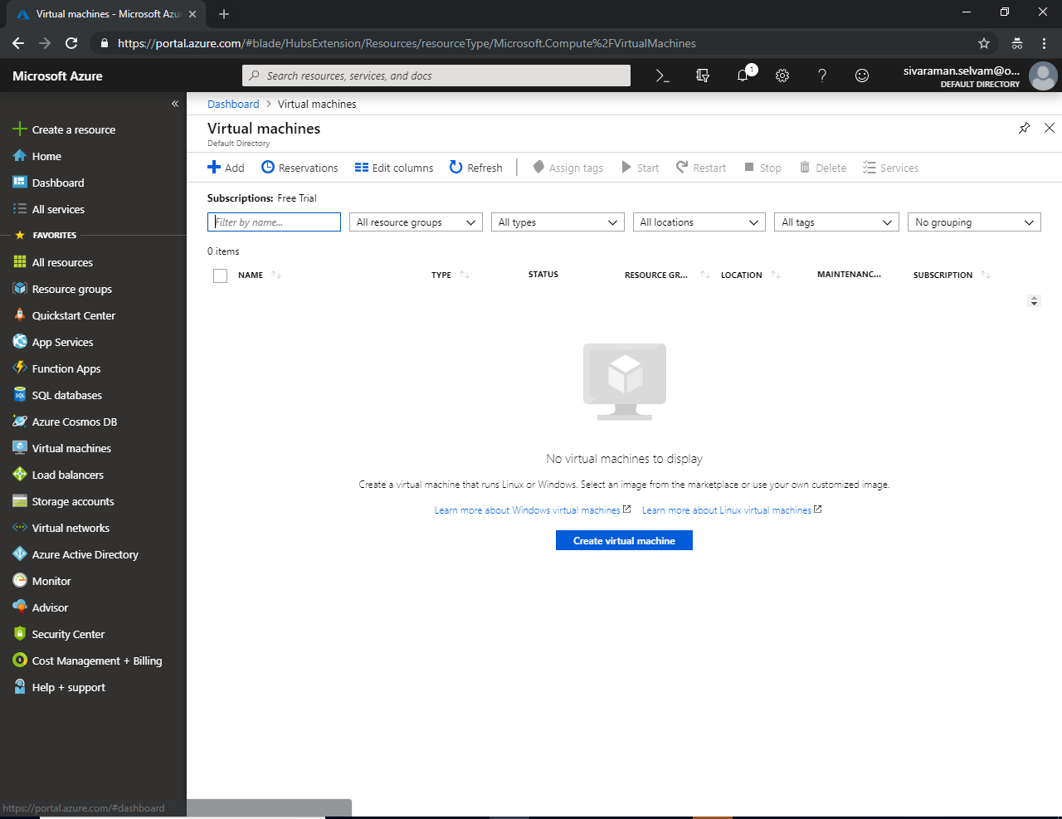

While create a virtual machine,

In “**Subscription”** 🡪 Select “Free Trial”.

In **“Resource Group”** 🡪 Click “Create new” to create new “Resource Group”.

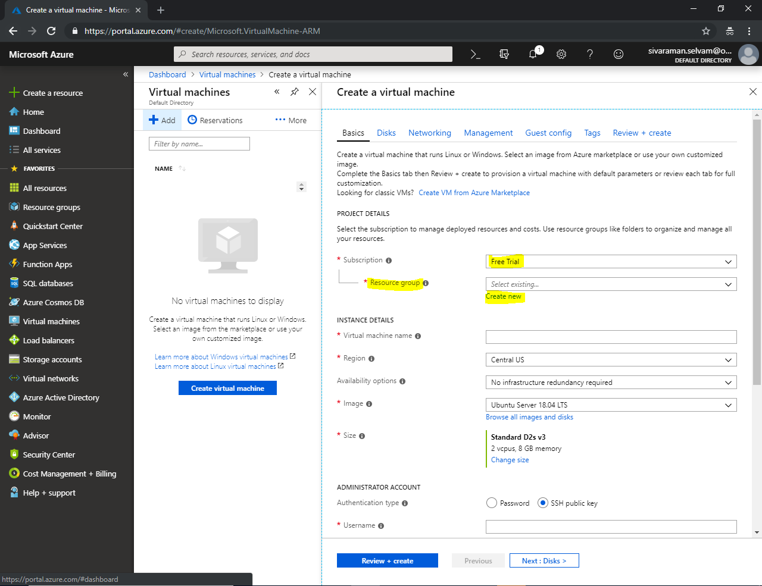

Type a **“Resource group”** name as **“SansboundAzureClass”** and Click **“Ok”**.

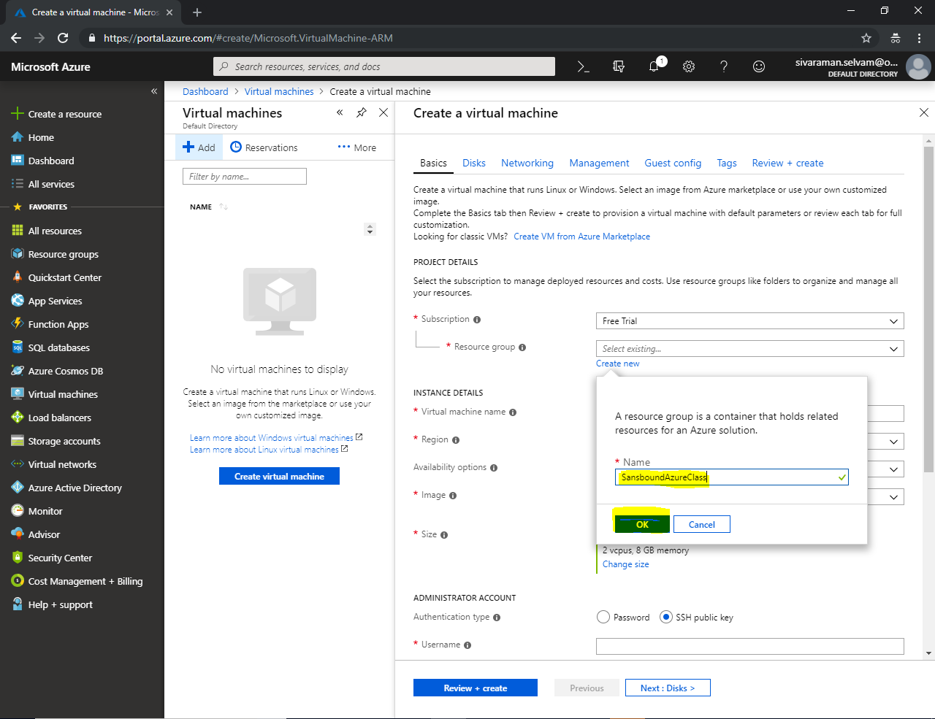

In “Instance details”

Type **“Virtual machine name”** as **“Windows-VM”**

Select “**Region”** as **“South India”**.

Select **“OS Image”** as **“Windows Server 2008 R2 SP1”**.

Also ensure that **“VM Size”** is changed as **“Standard B1s”**.

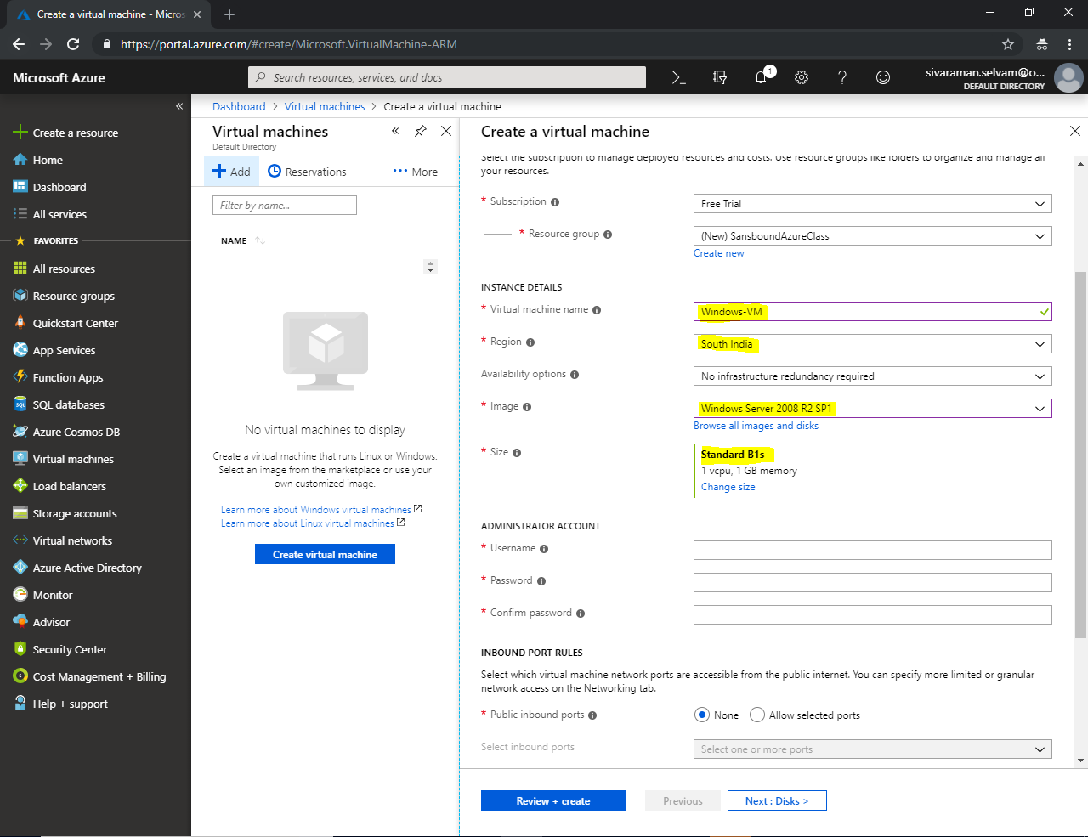

In **“Administrator Account”**, specify the username as **“sansbound”** and then type your own password to access the server.

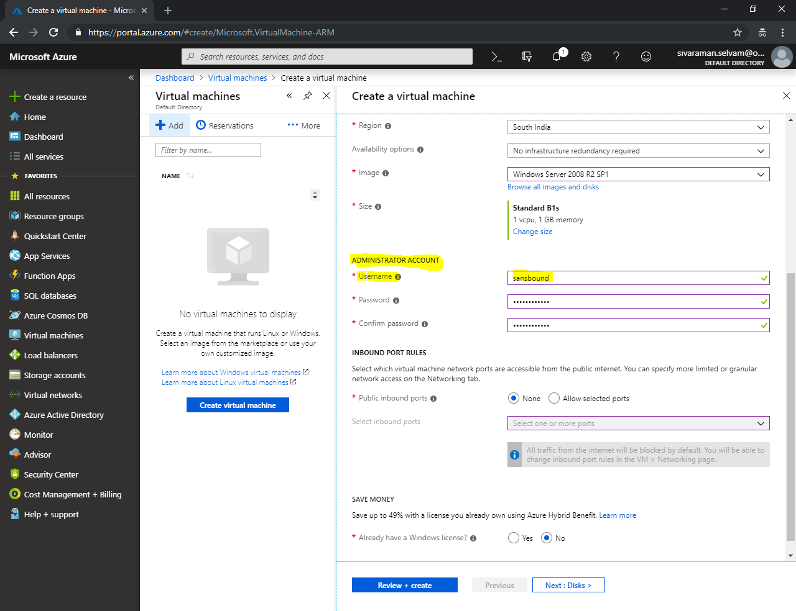

In **“Inbound Port Rules”,**

**In “Public inbound ports click “Allow selected ports” option.**

**In “Selected inbound ports”, you need to check the RDP (3389) Port to allow in inbound traffic.**

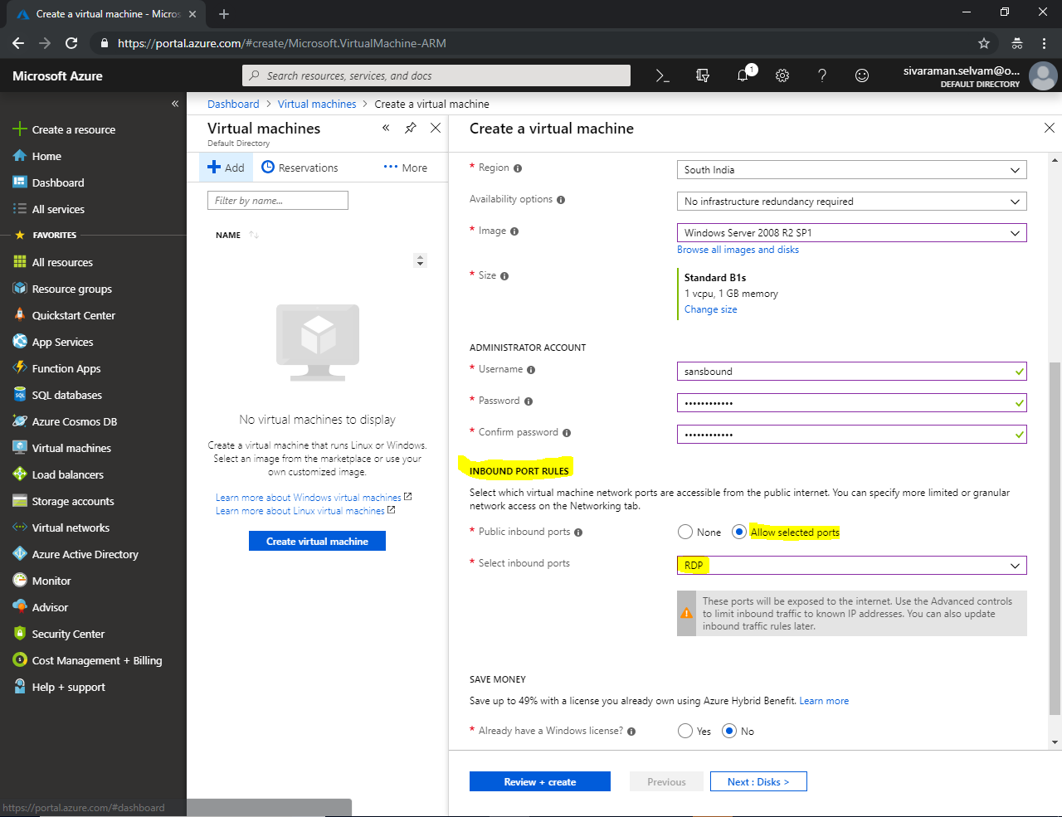

In **“Save Money”**

Click **“Yes”** option for **“Already have a Windows license”**.

Need to check the **“Confirmation”** box.

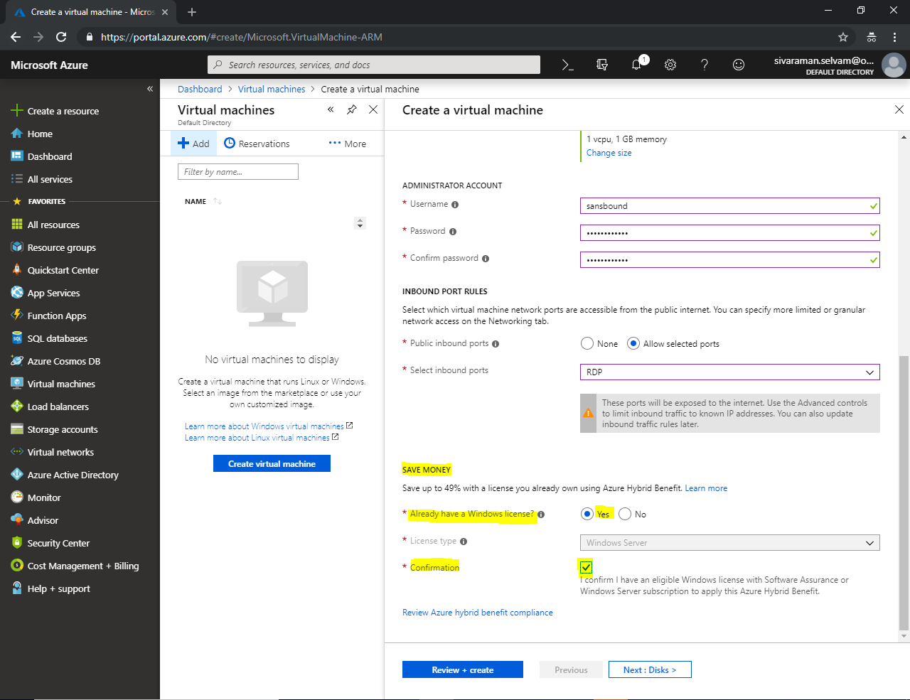



Click “**Next : Disks >**”.

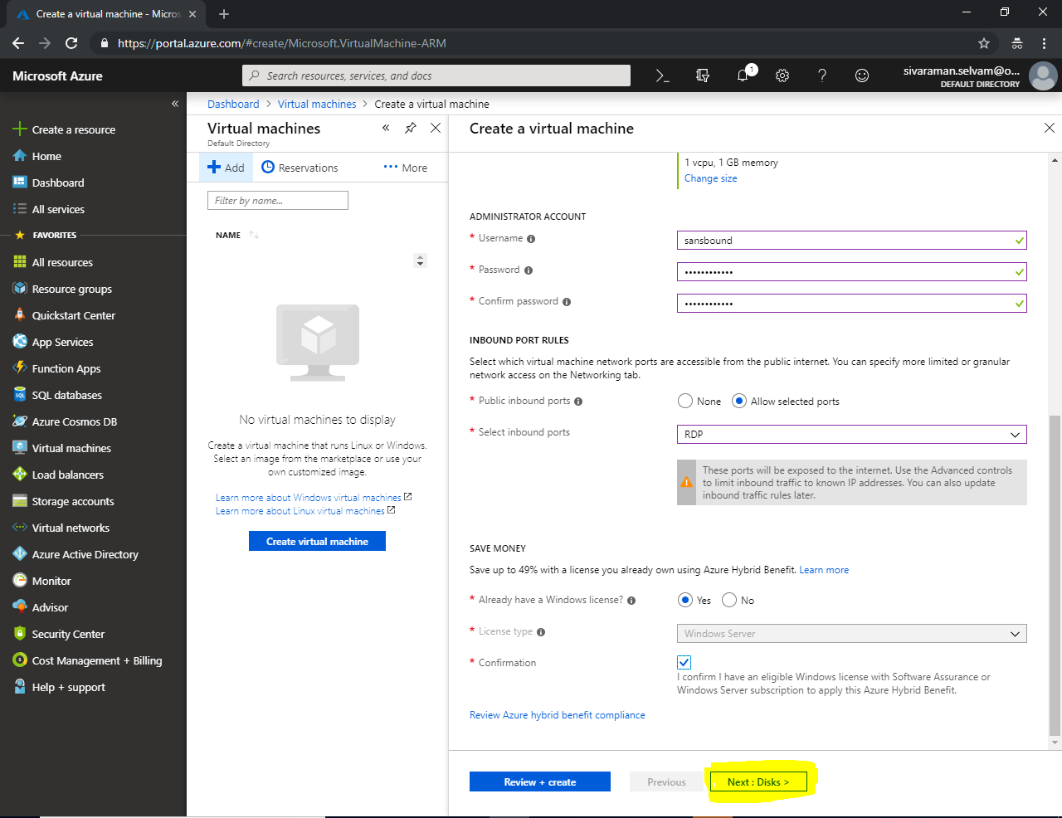

In **“Disks”**

Leave default settings and Click **“Next : Networking >”**.

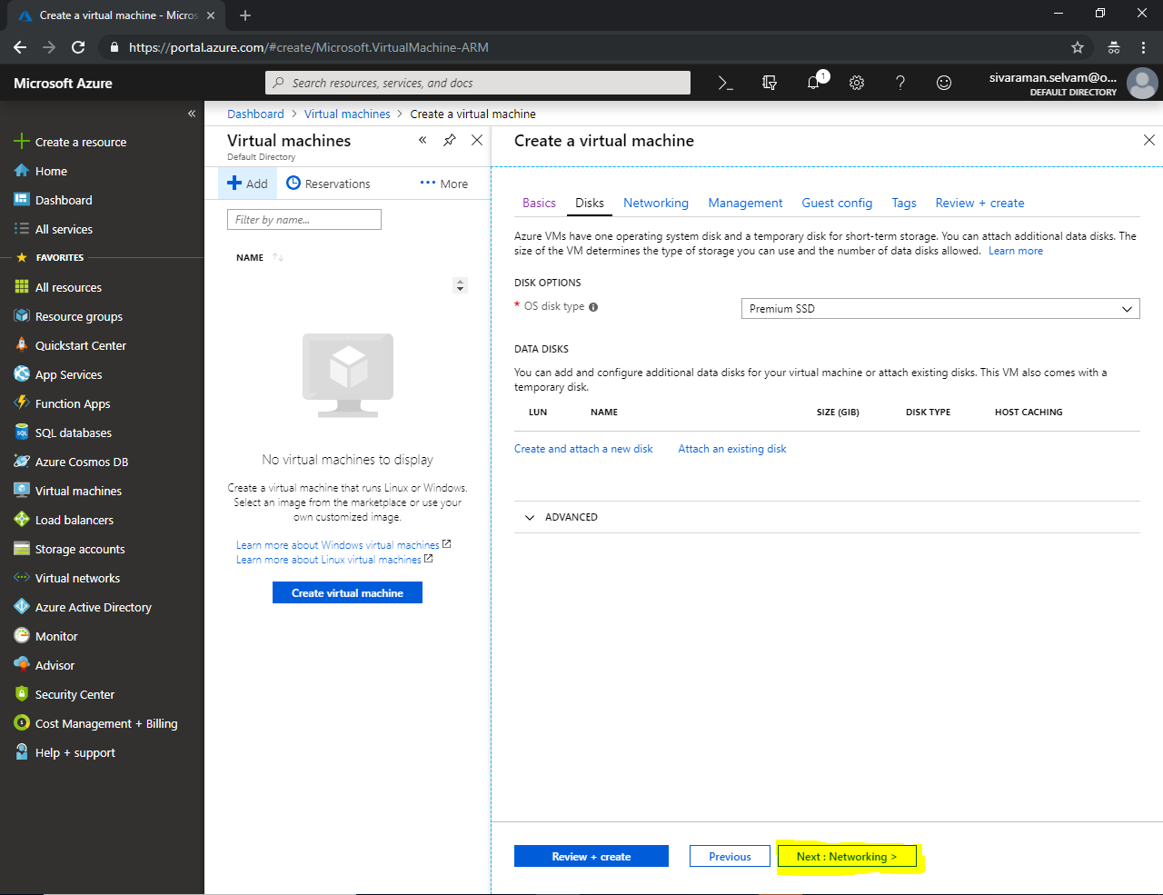

In **“Networking”**.

Leave default and click **“Next : Management >“**.

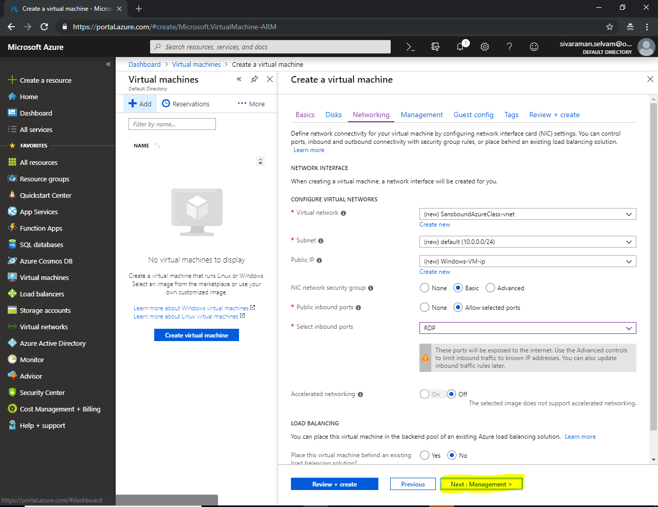

In “Management”

Ensure that all are in **“Off”** state, it’s your choice based on requirement you can on the features.

Click **“Next : Guest config >”**

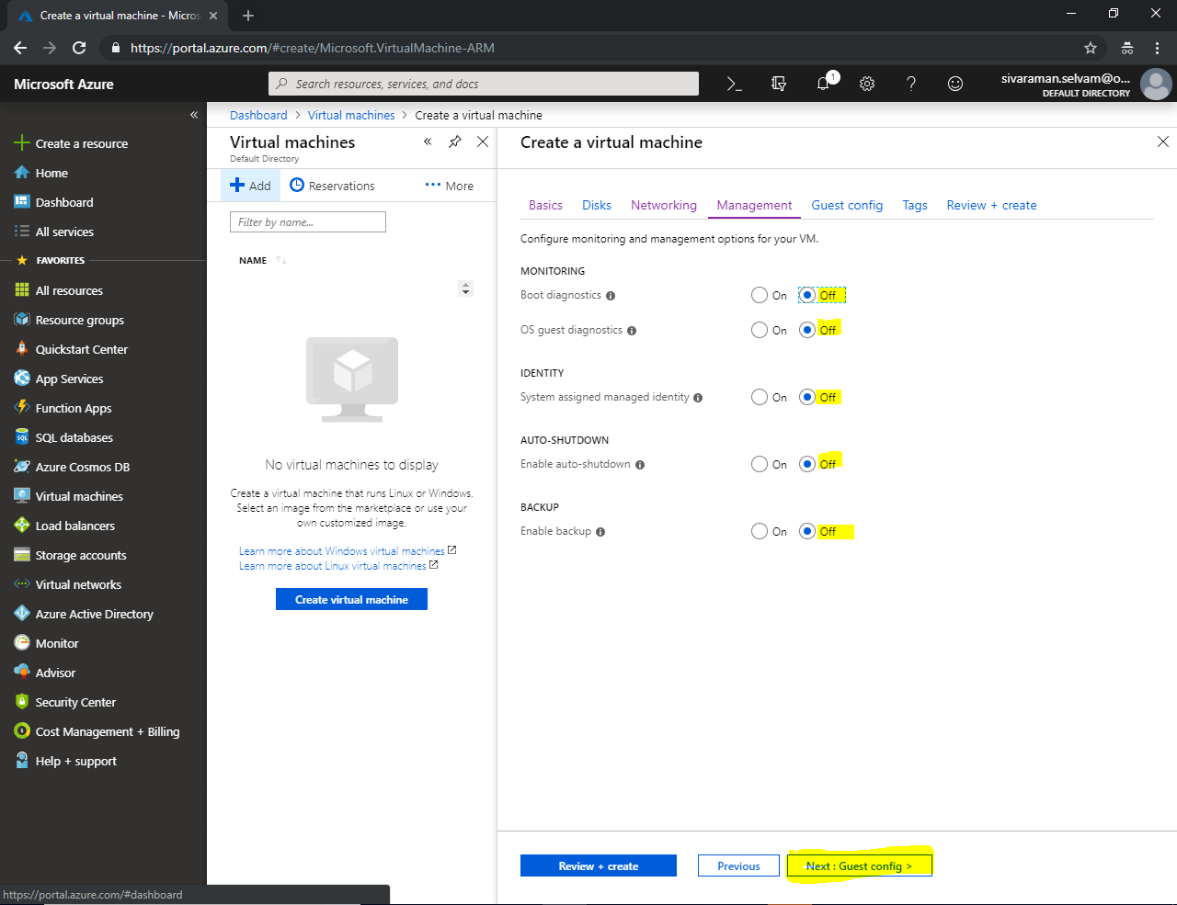

In “Guest config”

Leave default and Click **“Next : Tags >”.**

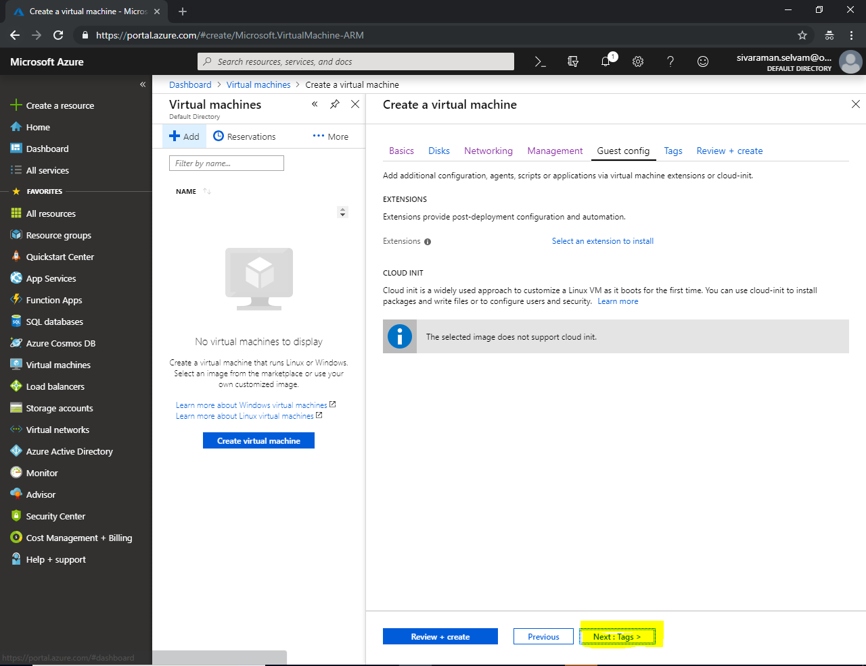

In “Tags”.

Leave default and click **“Next : Review + Create”**.

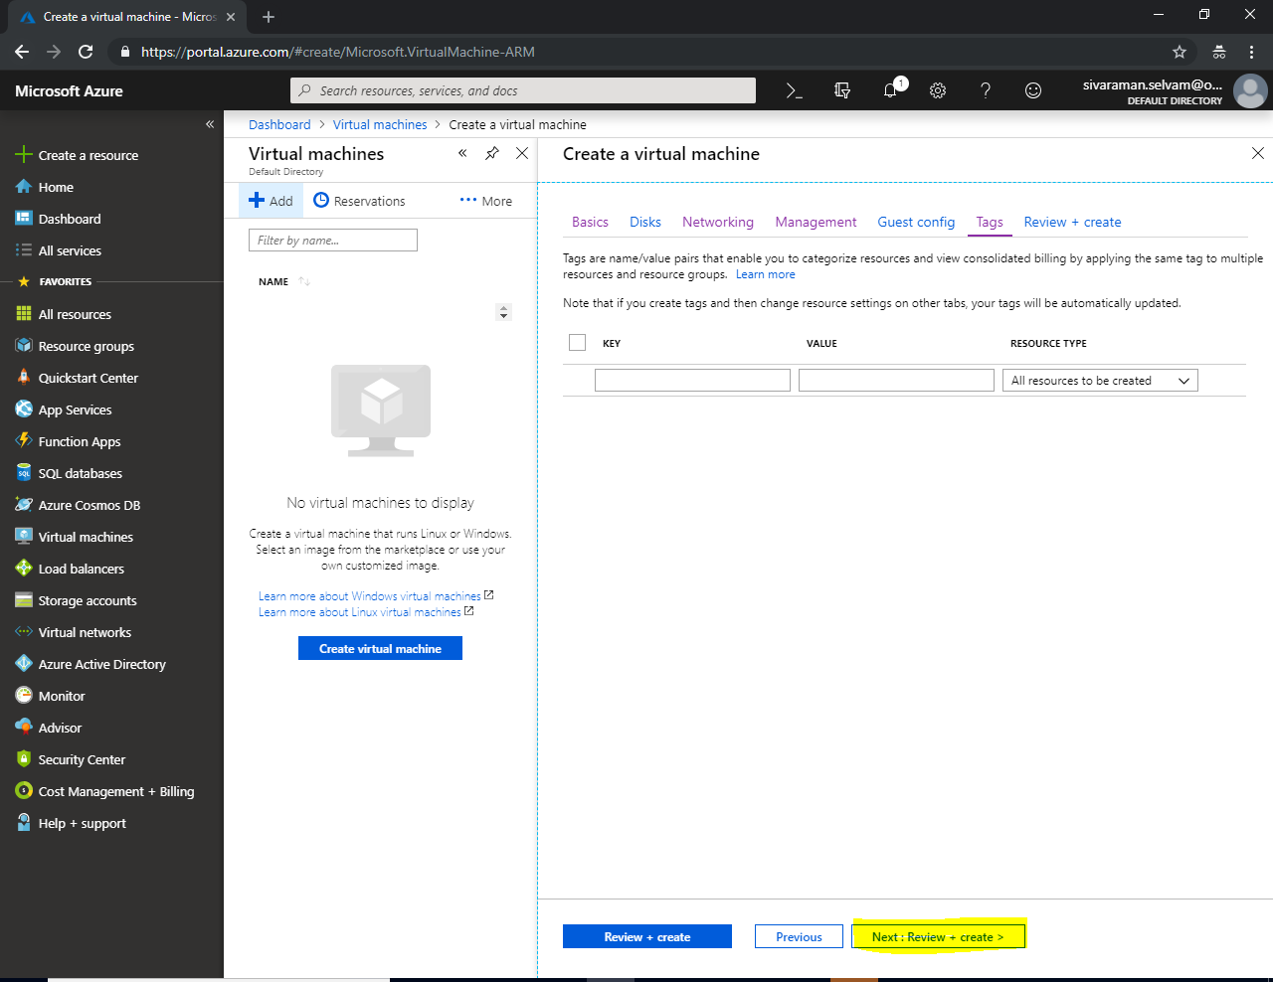

Click **“Create”**.

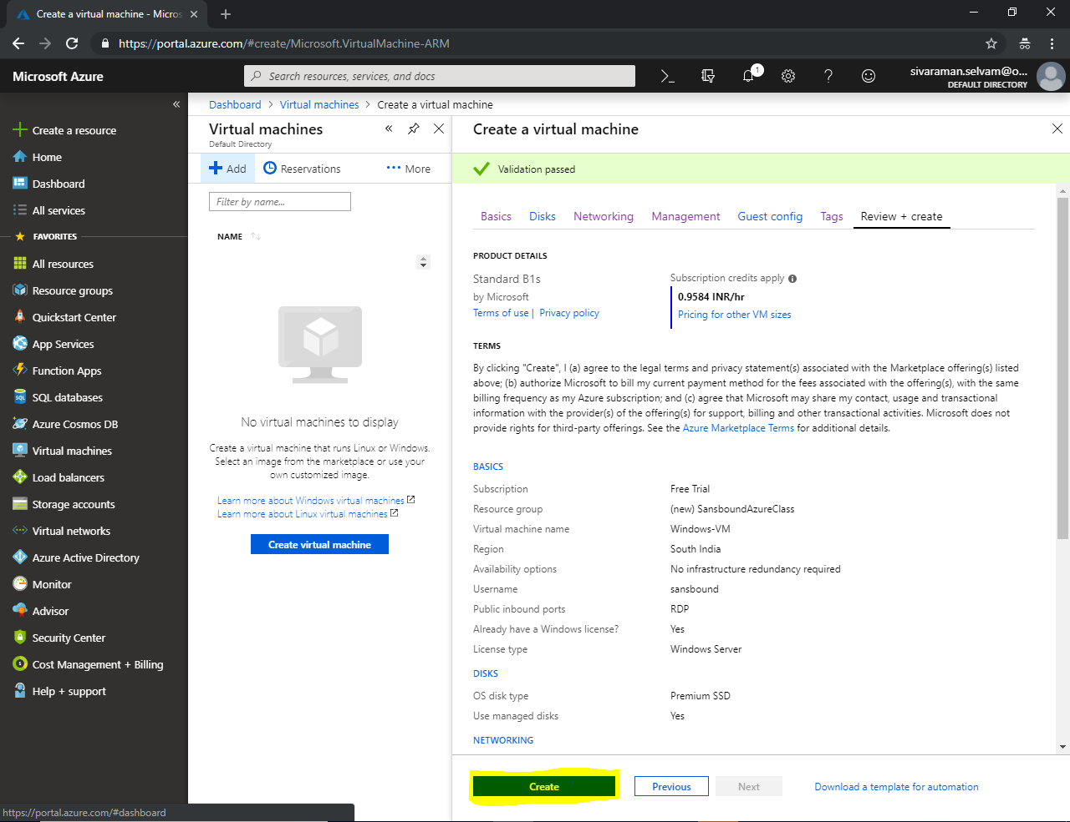

Your deployment has been completed.

Click “Go to resource”

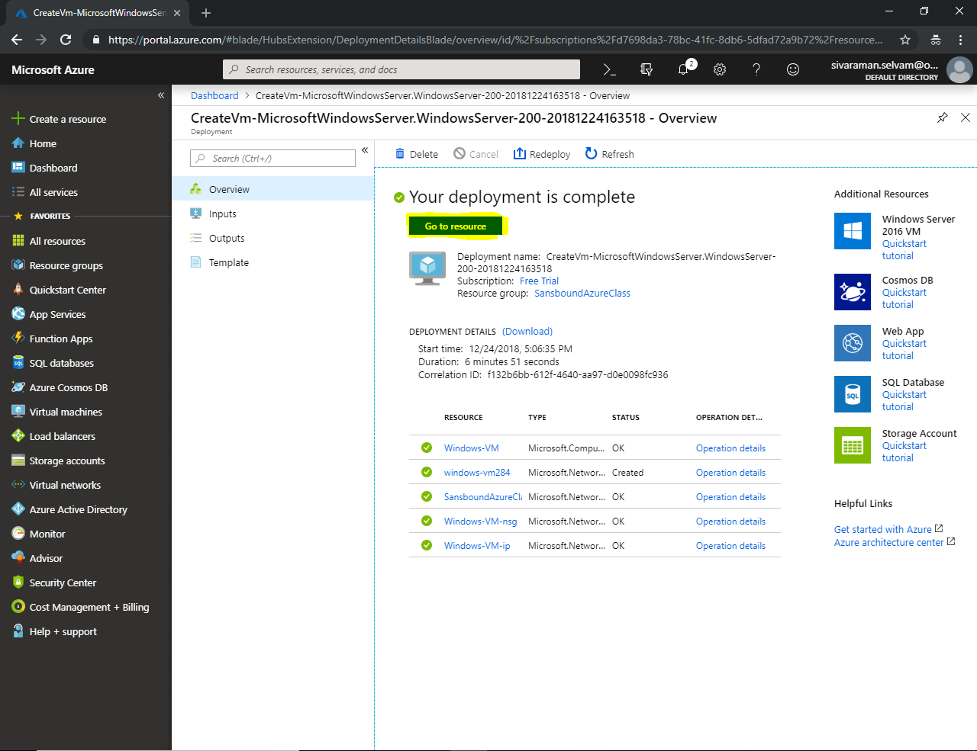

While creating a VM, below mentioned resources are automatically created by default based on user requirement.

1. Virtual Network (default) 🡪 It’s for virtual network
2. Virtual machine 🡪 It’s created for Virtual machine.
3. Disk which contain Operating system 🡪 It’s default disk created for operating system.
4. Network Interface 🡪 It’s used for Network Connectivity.
5. Public IP address for Virtual machine 🡪 It’s for access the resource publicly by using public IP address.
6. Network Security Group for Allow / Deny & inbound /outbound rules like as Firewall.

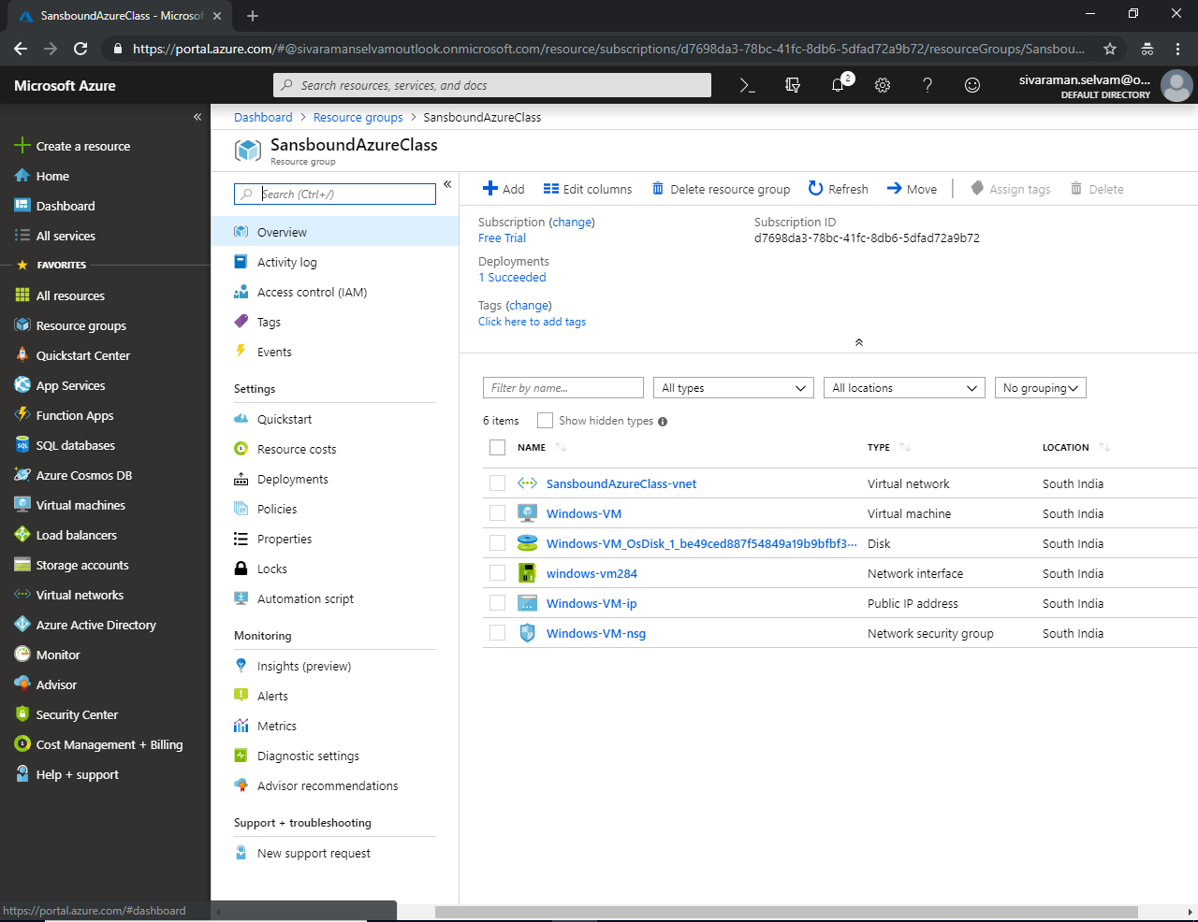

We will see above resources briefly later.